TITLE: Living Water

TEXT: John 4:10

Repentance: from my own way!

Living water. Water that makes you alive, successful, productive.

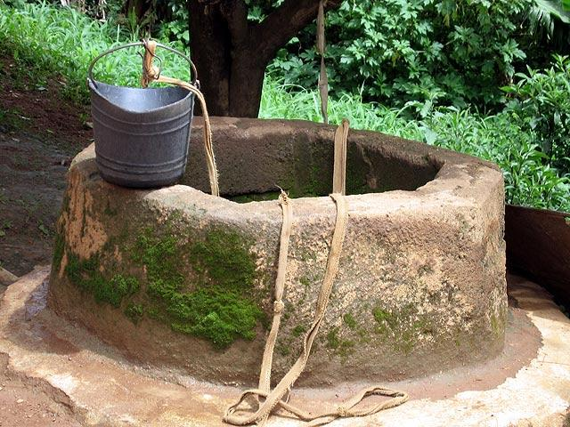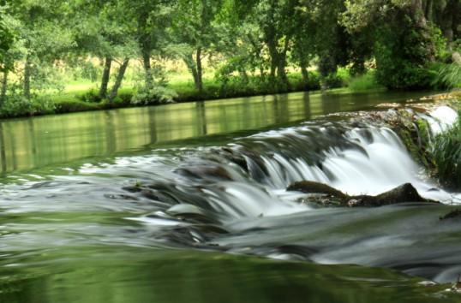

Genesis 13:13 *But the men of Sodom were wicked and sinners before the Lord exceedingly.*

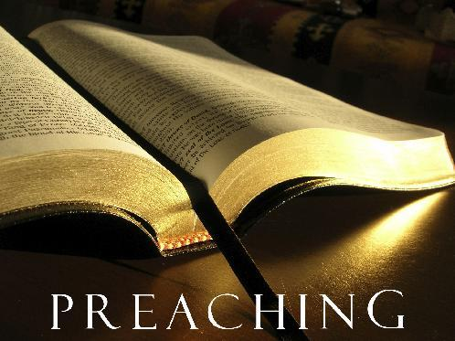

God knows when and how to give you living water.

LIVING WATER

I. The Lord knows when and how to give Living Water.

a. This Living Water is Everlasting Life.

b. This Living Water is what He gives to those that ask Him.

John 4:34 *Jesus saith unto them, My meat is to do the will of him that sent me, and to finish his work.*

II. The Lord knows when and how to make a move.

3 “He left Judaea, and departed again into Galilee”

4 “And he must needs go through Samaria”

John 4:1 When therefore the Lord knew how the Pharisees had heard that

Jesus made and baptized more disciples than John, 2 (Though Jesus himself baptized not, but his disciples,)

• Jesus does not run from the Will of the Father.

• Jesus does not run into trouble self-willed.

• Jesus does not force you against you’re will.

• Jesus does not answer just for a sign, He can and will give signs but

does not want us to just seek signs. It is time we know Him for ourself.

The Lord knows what you’re hearing

1. The Lord is not in competition

2. The Lord was in Submission

The Lord knows what you’re thinking

1. The Lord does not condone rivalry (Jews against Samaritans)

2. The Lord will have no rival with your affections

The Lord knows what and how you’re drinking

1. The drinking should be by faith in Jesus Christ

John 6:53 Then Jesus said unto them, Verily, verily, I say unto you, Except

ye eat the flesh of the Son of man, and drink his blood, ye have no life in

you.

54 Whoso eateth my flesh, and drinketh my blood, hath eternal life; and I

will raise him up at the last day.

55 For my flesh is meat indeed, and my blood is drink indeed.

56 He that eateth my flesh, and drinketh my blood, dwelleth in me, and I in

him.

Php 2:17 Yea, and if I be offered upon the sacrifice and service of your faith,

I joy, and rejoice with you all.

2Sa 23:15 And David longed, and said, Oh that one would give me drink of

the water of the well of Bethlehem, which is by the gate!

16 And the three mighty men brake through the host of the Philistines, and

drew water out of the well of Bethlehem, that was by the gate, and took it,

and brought it to David: nevertheless he would not drink thereof, but poured

it out unto the LORD.

17 And he said, Be it far from me, O LORD, that I should do this: is not this

the blood of the men that went in jeopardy of their lives? therefore he would

not drink it. These things did these three mighty men.

The Lord knows what you’re eating

Joh 4:32 But he said unto them, I have meat to eat that ye know not of.

Joh 4:34 Jesus saith unto them, My meat is to do the will of him that sent

me, and to finish his work.

The Lord knows how you’re living

Living from the natural

Jn.4:13 Jesus answered and said unto her, Whosoever drinketh of this

water shall thirst again:

22 Ye worship ye know not what: we know what we worship: for salvation is

of the Jews.

23 But the hour cometh, and now is, when the true worshippers shall

worship the Father in spirit and in truth: for the Father seeketh such to

worship him.

24 God is a Spirit: and they that worship him must worship him in spirit and

in truth.